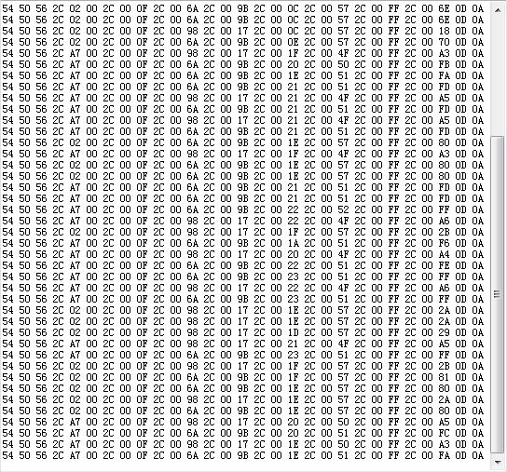

Green = data type Flag (0xA7 = common data, 0x02 = pressure leak data, 0x01 = low battery data)

Red = Sensor Id1, Id2, Id3

Black = Pressure

Blue = Temperature

Purple = Data integrity verification value

**Filtering steps:**

**1.** Compare the ID (3 red boxes value) with sensor IDs list on tpms_cfg.txt file. If doesn’t match any sensor, discard data. 90% of bad sensor data are filtered out on this step.

**2.** Data integrity verification value usage to filter out bad data (Checksum):

a) If Flag = 0x02, Checksum = (0x80 | Id1) + Id2 + Id3 + pressure + temperature + 0x77

b) If Flag = 0xA7, Checksum = Id1 + Id2 + ID3 + pressure + temperature + 0x77

c) If Flag = 0x01, Checksum = (0x40 | Id1) + Id2 + Id3 + pressure + temperature + 0x77

Note: (0x80 | Id1) means 0x80 “bitwise OR” Id1, example (0x80 | 0x0F) = 0x8F  
 (0x40 | Id1) means 0x40 “bitwise OR” Id1, example (0x40 | 0x0F) = 0x4F

**3.** Do not read temperature value when a pressure leak frame is received (flag 0x02), because temperature value will be false. Update only pressure information, which is very important.

**4.** Do not read temperature and pressure values when a low battery frame is received (flag 0x01), because values will be false. Update only low battery alarm in this case.